



***SMART FISH POND ENABLED WITH CLOUD APPLICATIONS***

*BATCH NO:****10***

*TEAM NAME*: ***ROLLY VORTEX***

*TEAM MEMBERS*:

**K.SAHITHI**

**A.SHIVA SREE**

**P.SATYA KRISHNA**

**INTRODUCTION:**

This project is to design and construct an automatic aquarium for those who cannot take care and keep an eye on their fish and aquarium daily and minimize the manual factor as much as possible. The aquarium will perform all the steps automatically like temperature control, turbidity level under control, feeding etc and would send all the information on cell phone via GSM Mobile.

A fish pond is only appropriate when there is a sufficient amount of land , a source of fresh water and a suitable climate. Water quality is an important parameter which dominates the quality of life of marine animals. Thus monitoring the quality of water is very important. Some of the important parameters of water to be monitored are water temperature and water quality . Fishes are cold blooded creatures and any variation in temperature of water hamper the growth of fishes .

Through This project we can monitor the water quality and water temperature by using some sensors. we can alert the concerned person if the water quality is poor and if the water temperature is in-appropriate so that he may take necessary precautions. the fishes has to be feed on time. if the person is not near the fish pond he may not feed them at the correct time and this may cause them a huge loss. To overcome that we can automate the feeding mechanism by keeping some motors.

**ABSTRACT :**

Fish keeping is a popular fad; almost people from all the age groups like to keep fish in their home, offices etc for decoration purpose or as a hobby. Fish keeping is itself an industry which comes in agriculture .Fish keeping is not an easy job; we always need an aquarium or a pond for that. The hobby of fish keeping is broadly divided into three; freshwater, brackish, marine. Among all these three, freshwater is considered to be the most popular hobby of keeping fish because it is easy to handle with freshwater fish and aquariums. It has always been a headache to take care of the fish and aquariums.

We have to change the water after sometime; we have to feed the fish on time, we have to maintain the temperature and turbidity level of the water and always have to keep an eye on fish and aquarium. All these steps are done manually .The project, SMART aquarium has been designed by keeping in mind, the problem of those who cannot take care of their aquarium every day.

It does the feeding itself every day, keeps the temperature of the aquarium under control, and also keeps the turbidity level under control. The GSM Mobile attached to it sends the report or we can say the current situation of the aquarium like temperature level, turbidity level, feeding etc via SMS on your cell phone

**HARDWARE COMPONENTS :**

* Water temperature sensor
* Turbidity sensor
* Arduino Uno
* PH sensor
* Node MCU ESP8266

**Water temperature sensor :**

This Maxim-made item is a digital thermo probe or sensor that employs DALLAS DS18B20. Its unique 1-wire interface makes it easy to communicate with devices. It can converts temperature to a 12-bit digital word in 750ms (max). Besides, it can measures temperatures from -55°C to +125°C (-67F to +257F). In addition, this thermo probe doesn't require any external power supply since it draws power from data line. Last but not least, like other common thermo probe, it stainless steel probe head makes it suitable for any wet or harsh environment

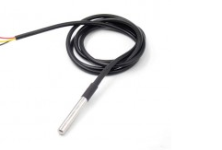

TURBIDITY SENSOR: The **TSD**-**10** is a **Turbidity Sensor** with phototransistor output. ... The **sensor** operates on the principle that when light is passed through a sample is dependent on the amount of soil in the water and as the soil increases the amount of transmitted light decreases.

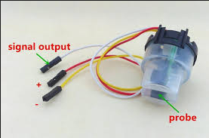

**PH SENSOR**:

**pH** probes measure **pH** by measuring the voltage or potential difference of the solution in which it is dipped. ... Hence, a **pH probe** measures the potential difference generated by the solution by measuring the difference in hydrogen ion concentration using the Nernst equation and displays the **pH** as output.

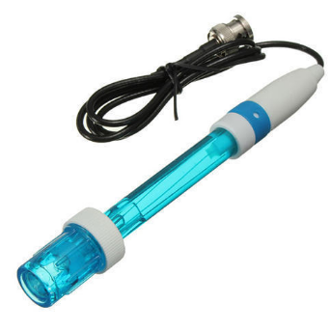

NODEMCU ESP8266 **:**

NodeMCU is an open source IoT platform. Which includes firmware which runs on the ESP8266 Wi-Fi Module from Espressif Systems,and hardware which is based on the ESP-12 module. The term “NodeMCU” by default refers to the firmware rather than the dev kits. NodeMCU firmware was developed so that AT commands can be replaced with Lua scripting making the life of developers easier. So it would be redundant to use AT commands again in NodeMCU.

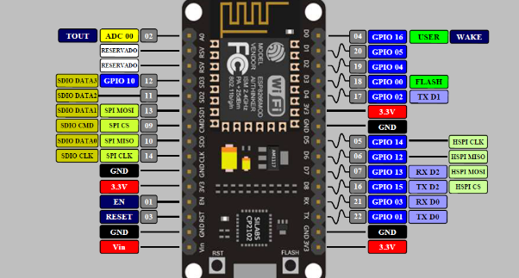

**ARDUINO UNO :**

[Arduino](http://arduino.cc/) is an open-source platform used for building electronics projects. Arduino consists of both a physical programmable circuit board (often referred to as a [microcontroller](http://en.wikipedia.org/wiki/Microcontroller)) and a piece of [software](http://arduino.cc/en/Main/Software), or IDE (Integrated Development Environment) that runs on your computer, used to write and upload computer code to the physical board.

The Arduino platform has become quite popular with people just starting out with electronics, and for good reason. Unlike most previous programmable circuit boards, the Arduino does not need a separate piece of hardware (called a programmer) in order to load new code onto the board -- you can simply use a USB cable. Additionally, the Arduino IDE uses a simplified version of C++, making it easier to learn to program. Finally, Arduino provides a standard form factor that breaks out the functions of the micro-controller into a more accessible package.

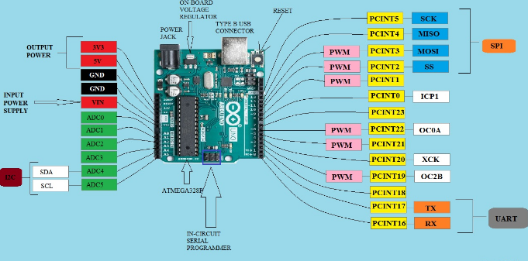

**SOFTWARE COMPONENTS** :

* ARDUINO IDE
* IBM CLOUD

**Methodology:**

The development of SMART aquarium can be divided into following major phases:

* Project design
* Analysis and, component level design and selection
* Assembly and hardware testing
* Simulation development and Verification
* Development for future implementation
* **Project Design:**

The Project design phase included mainly the determination of general layout and design of theSMART aquarium. The first step in this phase was the identification of design goals. Thefollowing things were required

* Dimensions of the aquarium

* Thickness of the glass

**Analysis and, component level design and selection:**

Once a general design was decided, we decided to make specific choices regarding componentselection and design. The estimate of 4 feet was kept as the maximum length of the aquarium sothat it could bear the pressure of the water in it. The thickness of the walls of aquarium wasdecided 600mm (estimated).

**Assembly and hardware testing:**

Once all components were selected and all major functional parts were designed, the major partof assembly and hardware testing of the different modules was done. In order to test the circuit, itwas first simulated on Proteus in order to minimize the hardware and circuit failure risks. Themechanical design was done on AutoCAD 2009. GSM Mobile, turbidity sensor, temperaturesensor, motors and different testing of other components was done and results were compared.

**Simulation development and Verification:**

Test results were simulated to achieve the desired goals and then they were verified to get thedesired outcome.

**Development for future implementation:**

When all the steps; design selection, components selection, components, modules and sensorstesting, simulation and verification was done, the work remained to be done was to make ourproject for future implementation, which included more advanced components, sensors, modules etc.

BLOCK DIAGRAM :

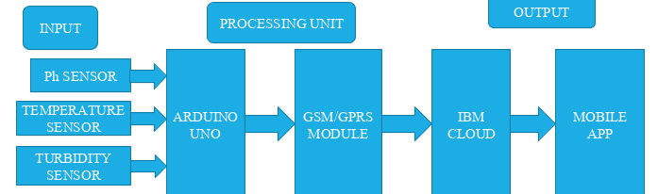

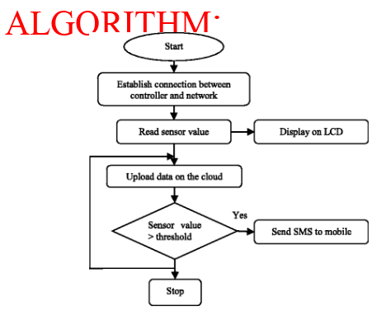

**CODE :**

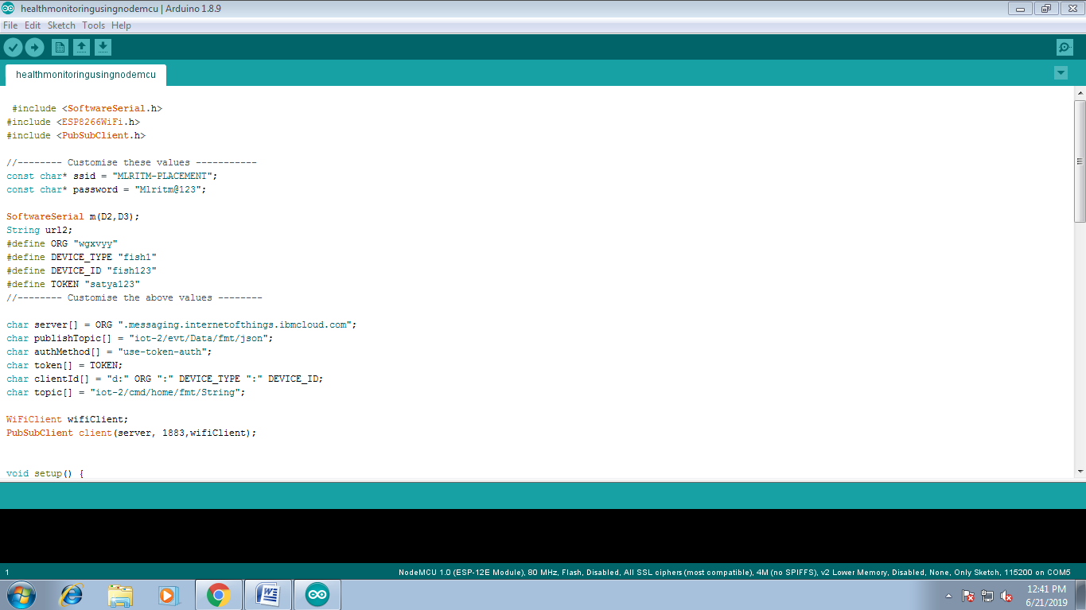

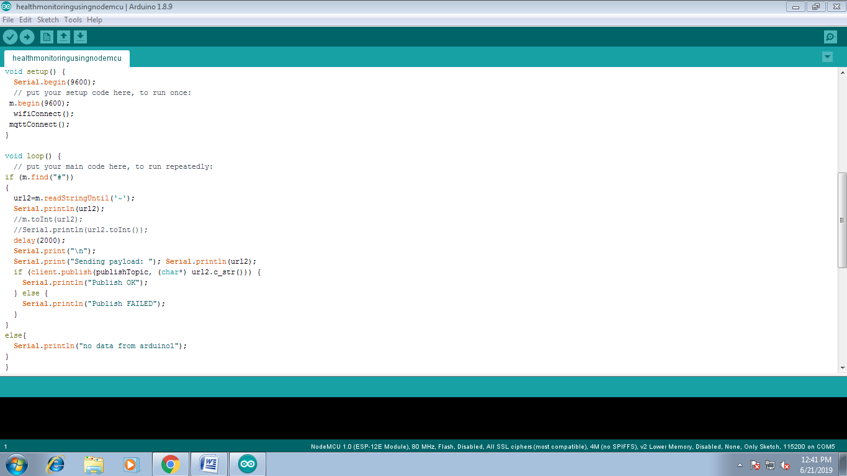

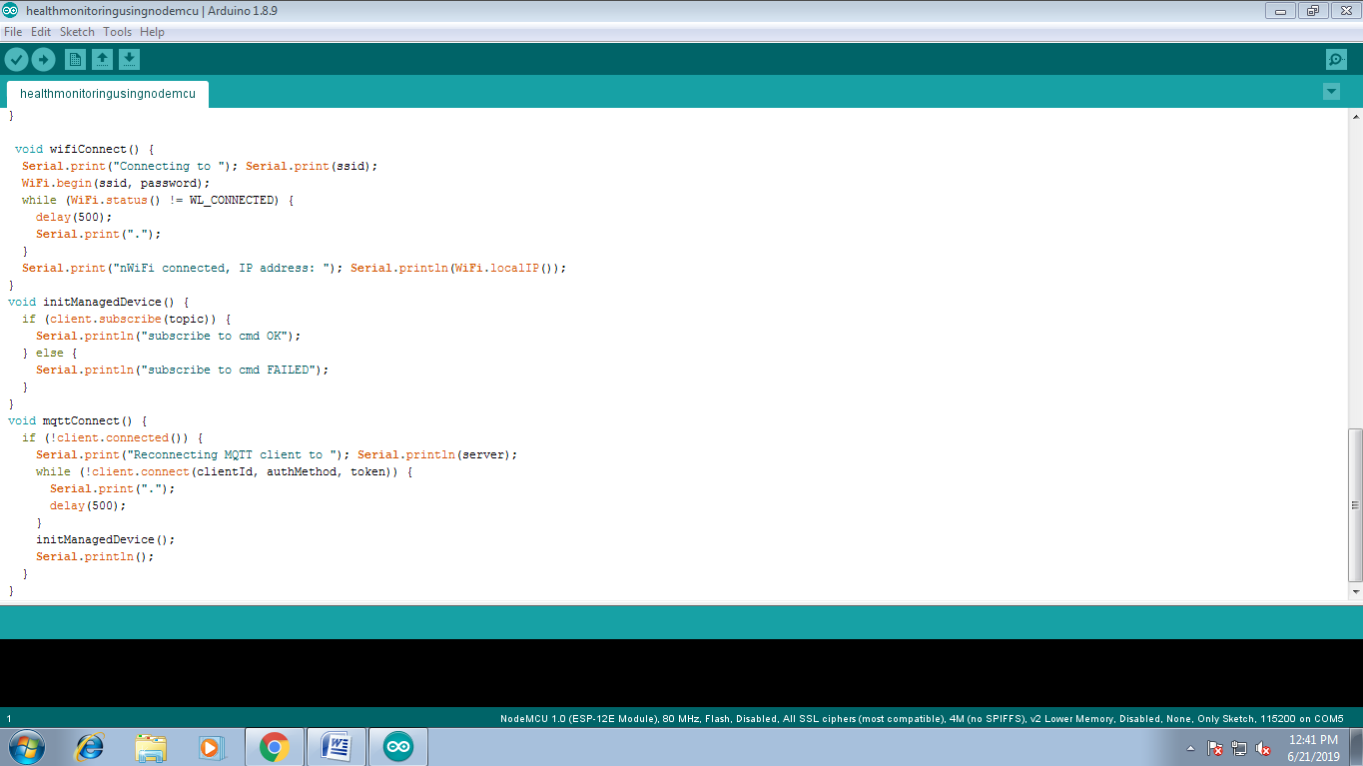

**SERIAL MONITOR :**

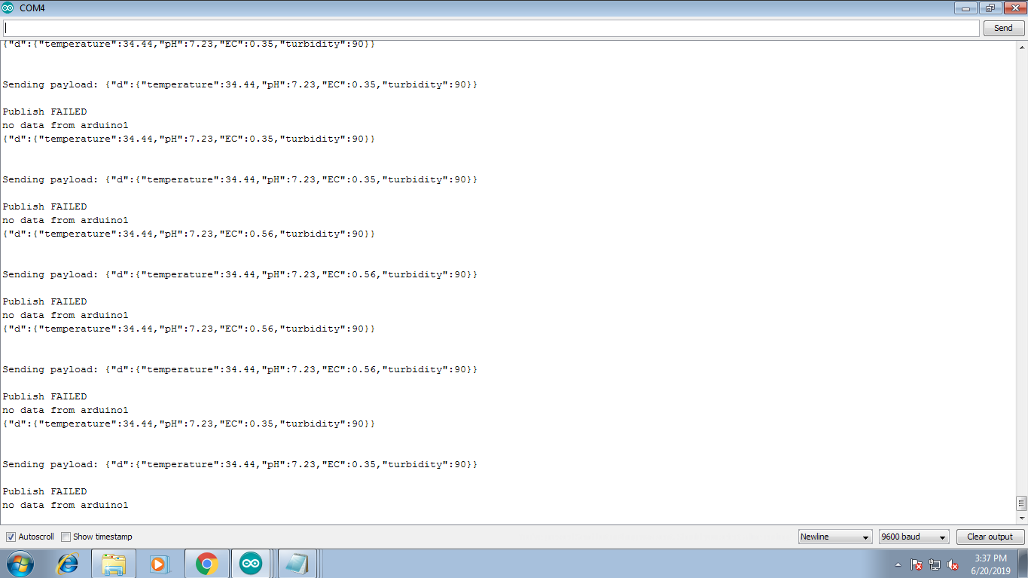

**NODE RED :**

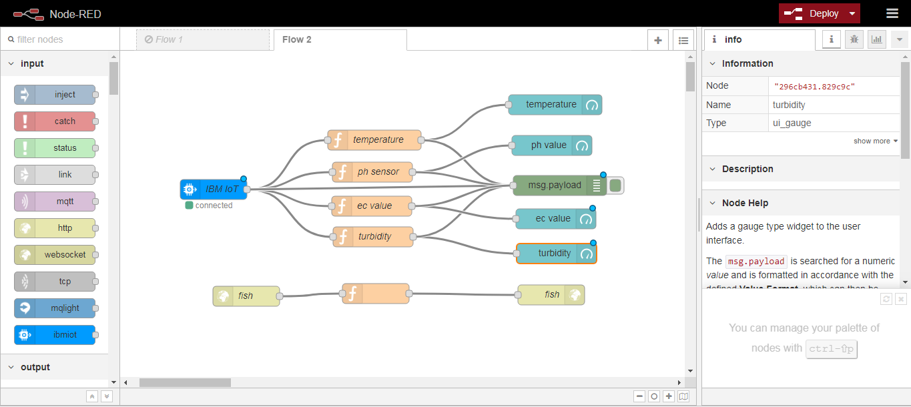

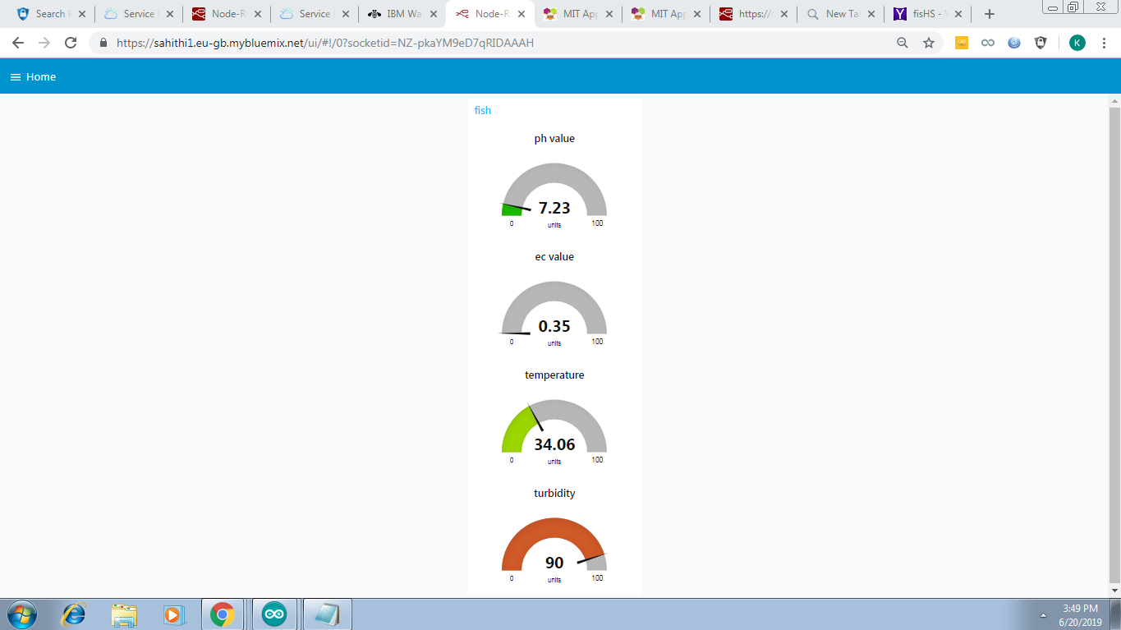

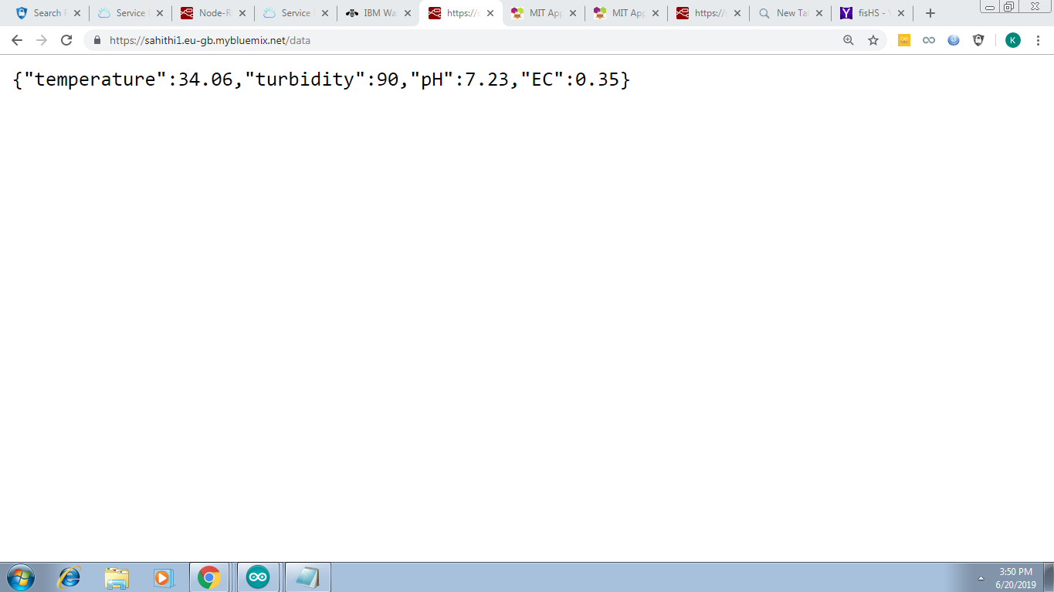  
MIT APP INVENTOR :

* DESIGNER

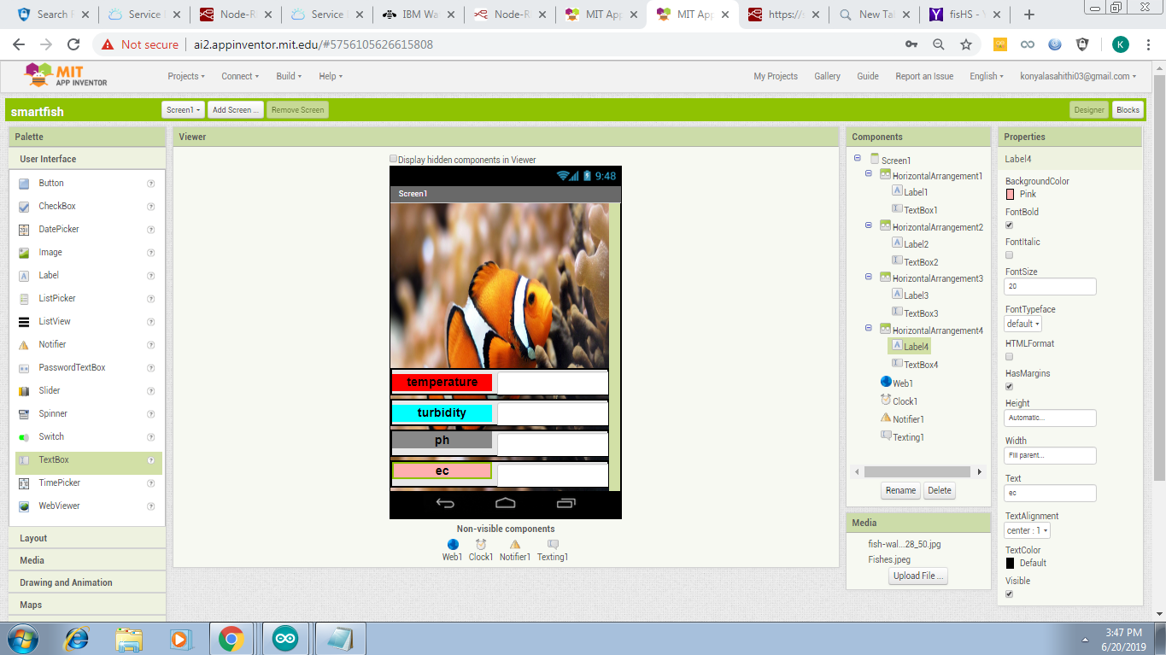

* **BLOCKS :**

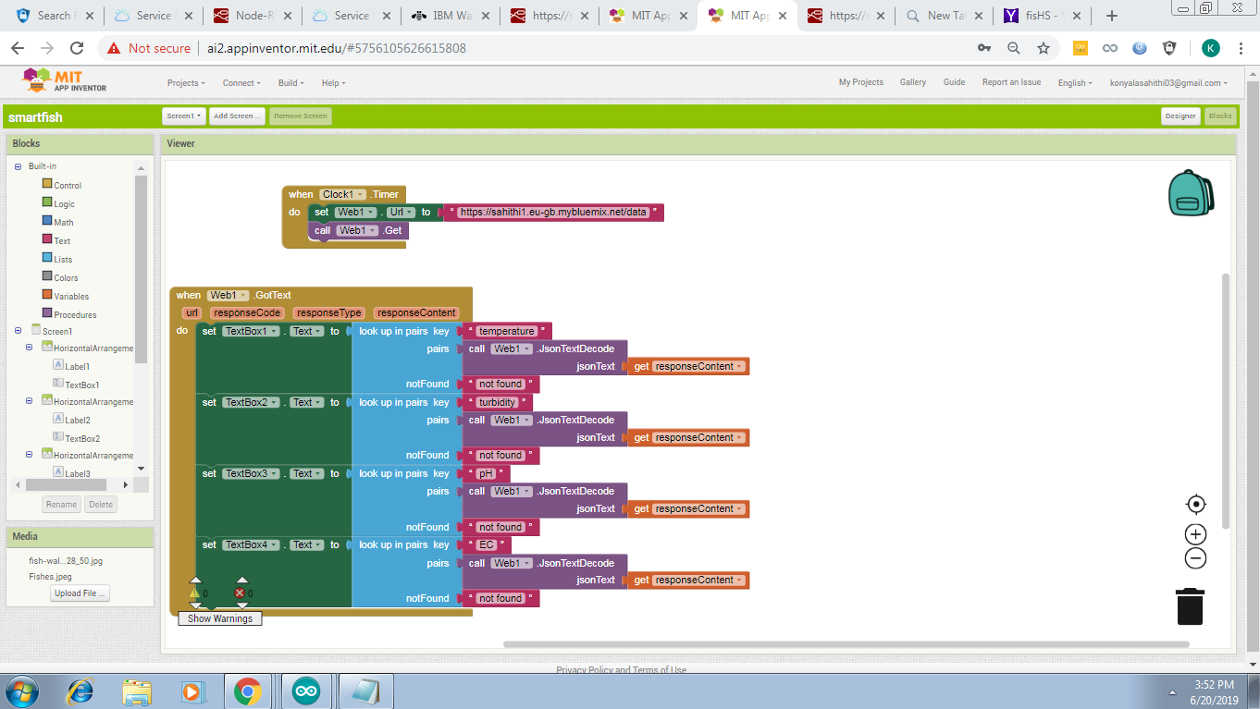

**MOBILE APP :**

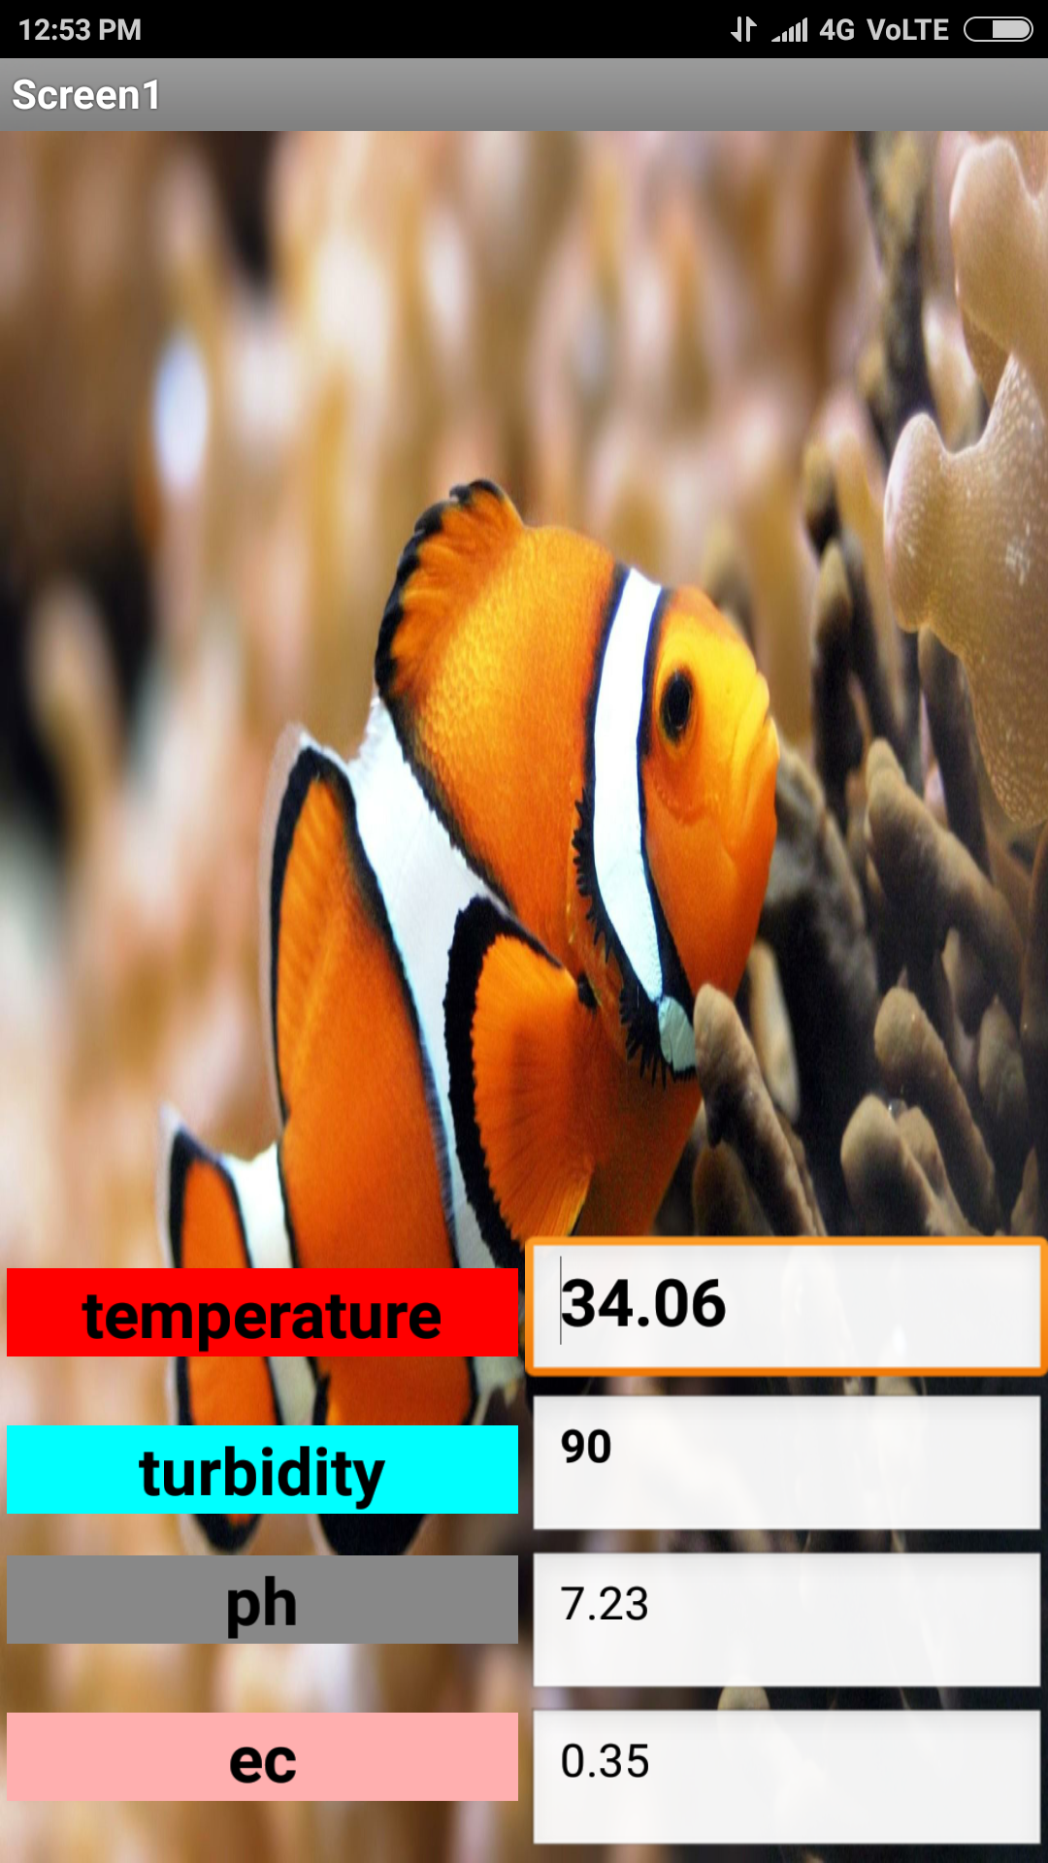

**Project Highlights:**

* GSM/GPRS communication between device and ThingSpeak cloud platform
* ThingSpeak cloud integration between device and mobile App
* Sending necessary alerts to the desired person
* Controlling the motor through mobile Application

**ADVANTAGES :**

**1.To monitor the water quality in real time to**

**ensure safe supply of water.**

**2. To monitor the water quality by measuring**

**various water quality parameters such as**

**dissolved oxygen, conductivity, and turbidity**

**using various sensor.**

**3. To perform real time water quality**

**monitoring by using Internet of things.**

**DISADVANTAGES :**

**1.Requires manual operation to submit data,**

**some configuration required.**

**2.Costly, usually only feasible under Exchange**

**Network grants**

**3.Technical expertise and network server**

**required.**

**CONCLUSION :**

* Price effective
* Eco friendly
* Safest technique
* We have developed an automated aquarium which controls parameters such as temperature, pH. We have incorporated an automatic feeder .